Zipdev – JavaScript code challenge

This is a simple front-end code challenge created to serve the following purposes:

1. How do you approach a problem
2. How do you communicate your solution
3. Show off your coding skills

### Required Functionality

Create a Quiz game with the following questions and at the end show the results and San Diego restaurants advertising.

Feel free to provide a simple design you consider appropriate.

#### Question number 1 – single answer

How do you describe yourself as a developer?

Hermit / Sociable / Serious / Grumpy / do not know yet

#### Question number 2 - Multiple Answer

Select the JavaScript based technologies:

AngularJS / Ember / VueJS / Java / C#?

#### Question number 3

Ask the user for introducing a palindrome

#### Question number 4

Present two textboxes to the user, first of them asking for a sentence and the second one the same sentence in reverse

At the end of the quiz, show a results page showing the following

1. Answers from the question number one highlighting the provided by the user
2. Answers from the question number two with an approval mark if the user selected the right answers
3. Show the word provided in the question number three and mark as good if the user provided a palindrome and wrong if not.
4. Show the two texts provided by the user and mark as good if the user provided a palindrome and wrong if not.
5. Show a message saying “Select your favorite San Diego restaurant” and display a list of San Diego Restaurants in the following format

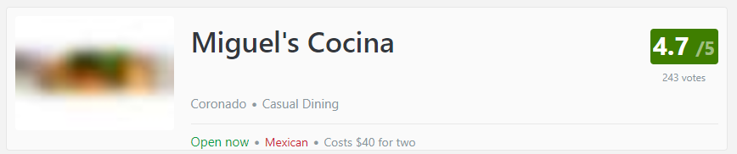

API to consume San Diego’s restaurants is here: <https://developers.zomato.com/api>

Requisites

* Show one question at time, and click next button for showing the next image
* Create a general progress bar at the bottom of the quiz (will fulfill the entire progress bar when you answer the last question)
* Ten seconds timer for the first two questions
* Responsive design
* Provide your code in a git-based repository
* Provide instructions to install it (readme file)
* You are free to provide information about the decisions you made implementing the code challenge.

Required technologies:

JavaScript

CSS

HTML5